**Student Name: Shinde Smita Shahaji**

**UID: 20BCS4643**

**Date of Performance: 23/04/2021**

**Branch: CSE_IOT Section/Group: IOT_B**

**Subject Name-Digital electronics**

**Aim**

**Design a home appliance control system with 3-to-8 decoder.**

**Task to be done**

*(Objective of the task to be explained)*

Home appliance control system has to be Design and Implemented using 3 to 8 Decoder.

**Requirements**

*(Hardware and software requirements)*

# Software –

Multisim live

# Hardware –

|  |  |  |
| --- | --- | --- |
| sr.no | Apparatus | Quantity |
| 1. | Digital constant | 4 |
| 2. | And gates | 8 |
| 3. | Inverter | 3 |
| 4. | Connecting wires | As per requirement |
| 5. | Led | 8 |

**Circuit diagram/ Block diagram**

*(Insert circuit diagram here)*

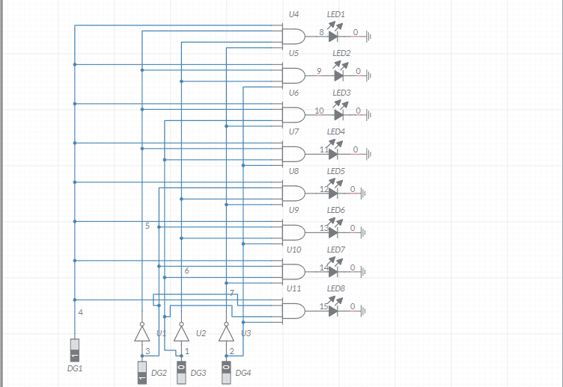

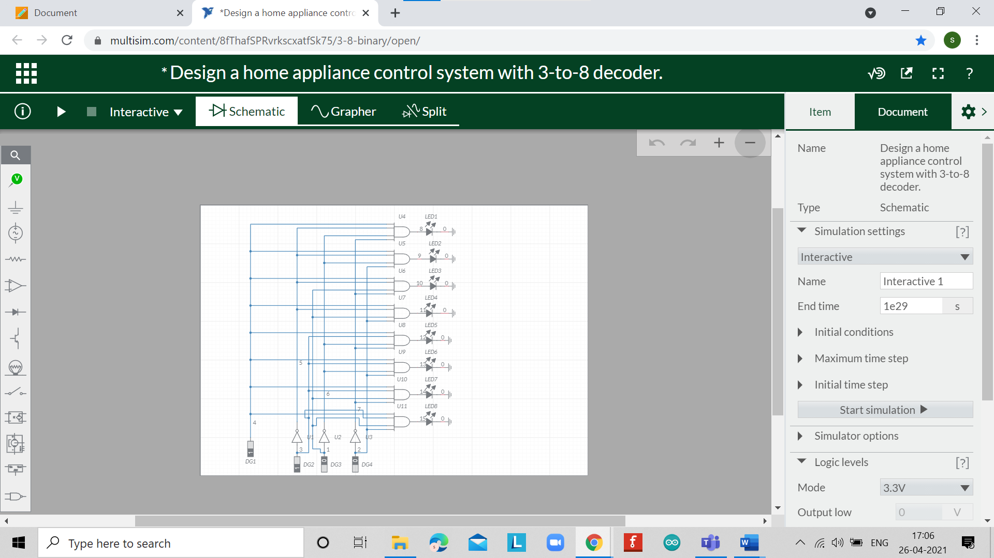

**Simulation Results:**

*(Insert simulation results )*At input 000 1st led is glowing

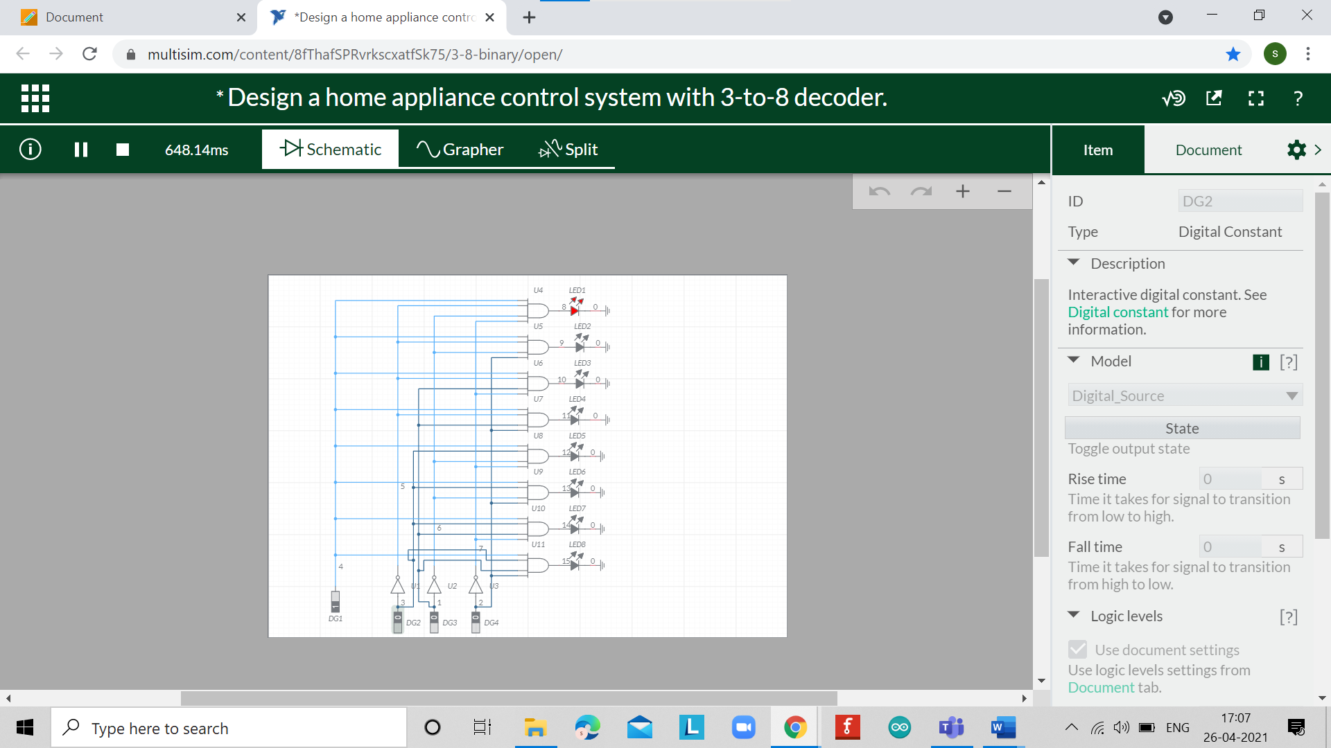

At input 010 3rd led is glowing

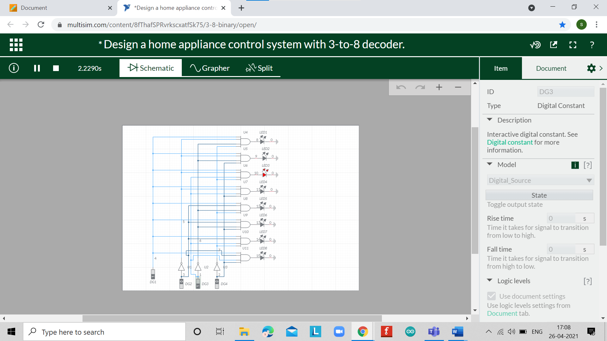

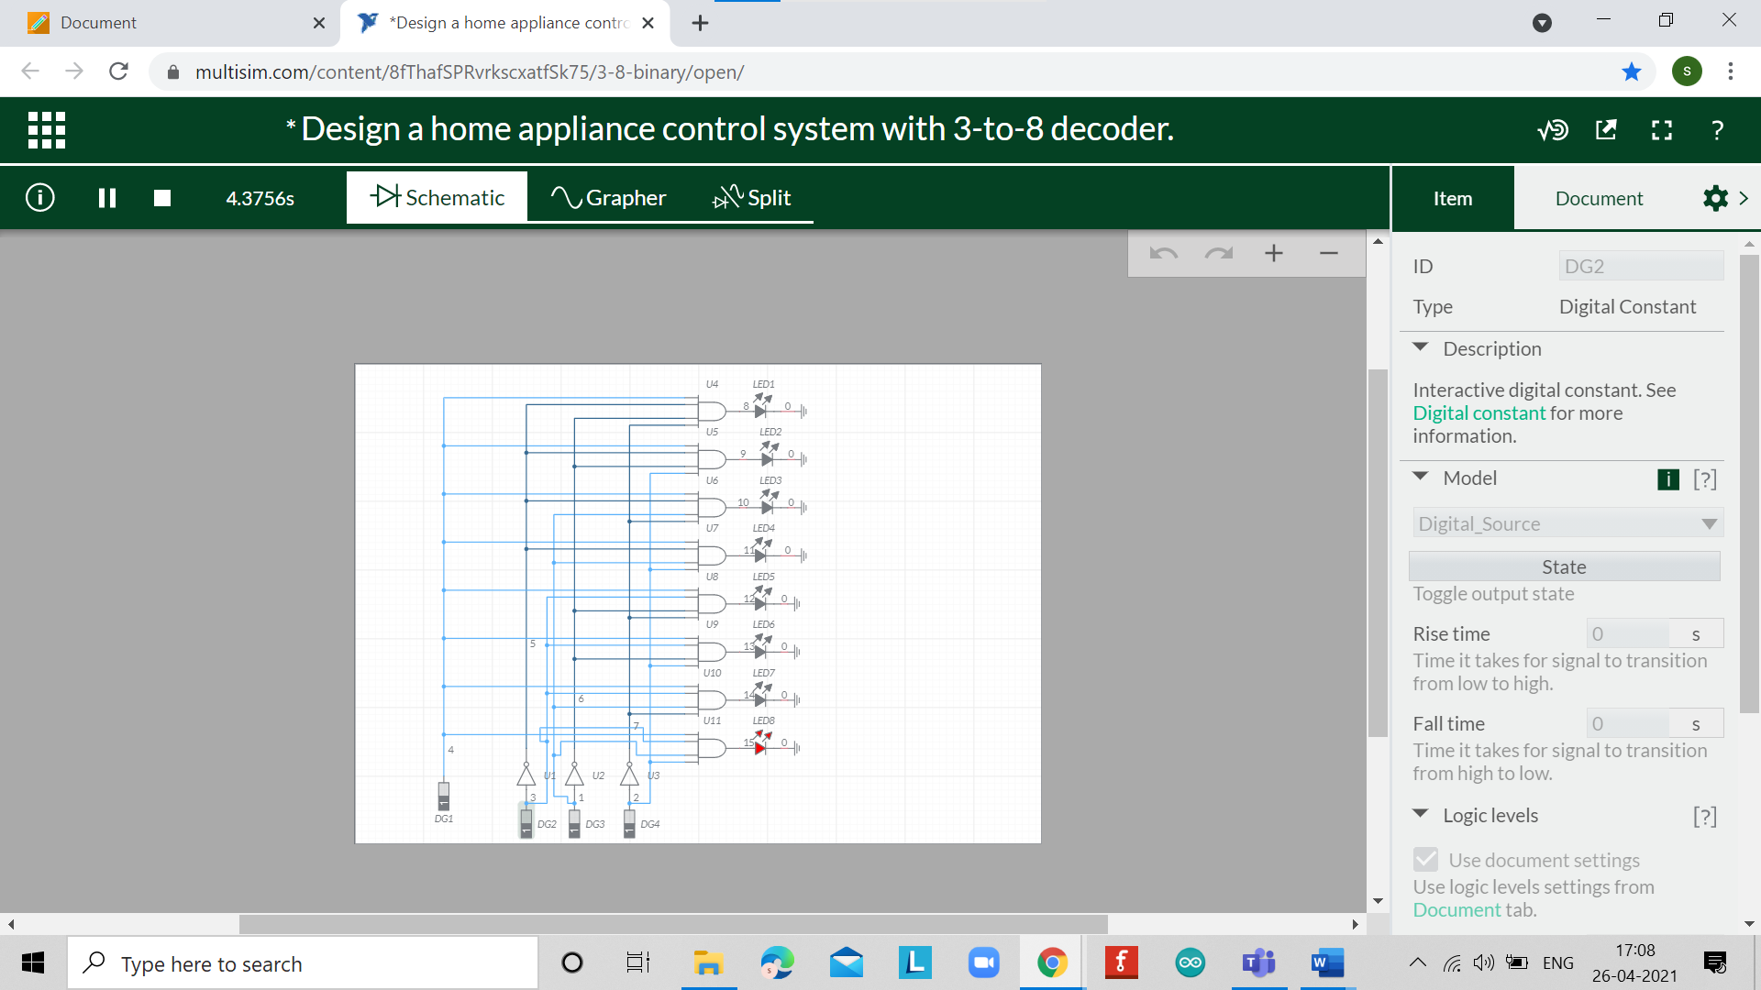

**Concept used**

*(Point out the concepts used in order to design the solution)*

* Here the outputs are connected to LED to show which output pin goes LOW and do remember the outputs of the device are inverted
* We are using a single device so we will connect G2A and G2B pin to ground followed by connecting G1 to VCC to enable the chip. The three buttons here represent three input lines for the device.
* As shown in table first three rows the enable pins needed to be connected appropriately or irrespective of input. lines all outputs will be high. After connecting the enable pins as shown in circuit diagram you can use the input. line to get the output.
* After powering, if all buttons are not pressed Y0 will be LOW and remaining output will be HIGH as shown in table.
* After only B1 is pressed, A0=HIGH and Y1 will become LOW while remaining will be HIGH.
* Following if only B2 is pressed, A1=HIGH and Y2 will become LOW while remaining will be HIGH.
* This way we can realize all the truth table by toggling the three buttons B1, B2 and B3 (Three inputs A0, A1 and A2) and with that we have three input to eight output decoder.

**Learning/ observation**

*(Observations made during the experiment and learnings for future reference)*

* The design is also made for the chip to be used in high-performance memory-decoding or data-routing applications, requiring very short propagation delay times.
* In high performance memory systems these decoders can be used to minimize the effects of system decoding.
* The three enable pins of chip (in which Two active-low and one active-high) reduce the need for external gates or inverters when expanding

**Troubleshooting**

*(Problems encountered and how did you solved those)*

For this experiment we have to give the IC74LS138 IC but it is not present on the software web thinker cad ..so for this experiment we are using new software platform which is Multisim live which is very new flatform for us so its quite difficult to design circuit than tinker-cad. But after sometime I get to know how to find and attach with other component then it’s easy to design and time will reduced after get to know how to do all and problem was solved .

**Result:**

Home appliance control system has been Designed and Implemented using 3 to 8 Decoder.